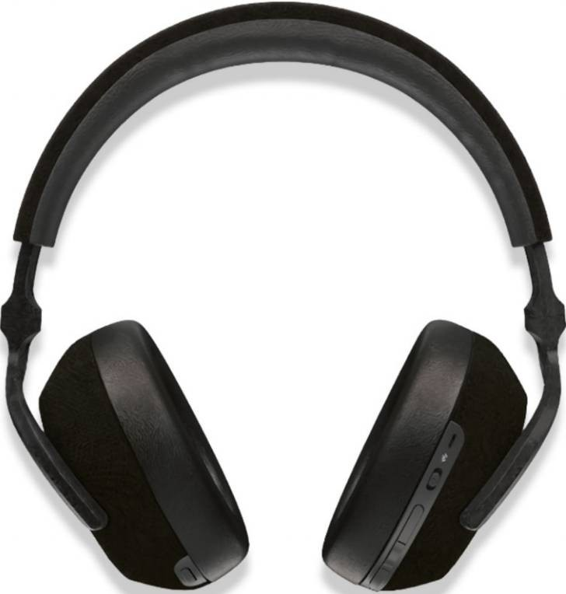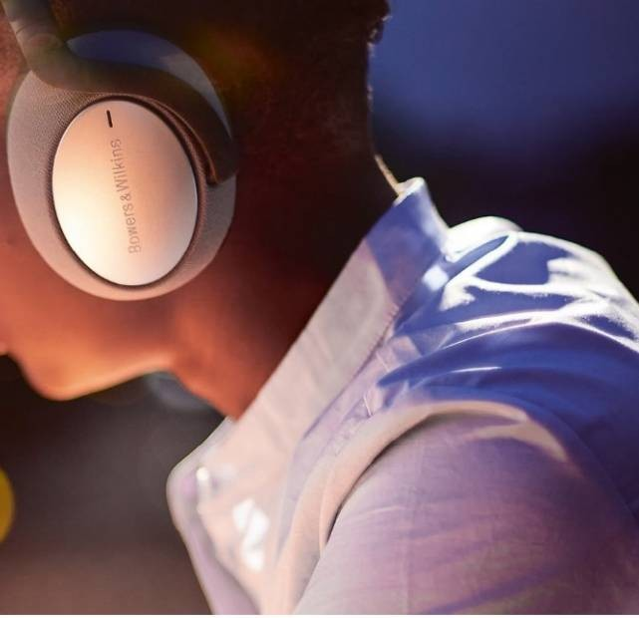

Built from legend

The 43.6mm drivers in the PX7 are the largest in our headphone collection and are developed and tuned by the same engineers behind the Bowers & Wilkins 800 Series Diamond loudspeakers found in Abbey Road Studios.

Cancels noise clean out

Adaptive noise cancelling that automatically responds to your environment, keeping the outside world out of the music.

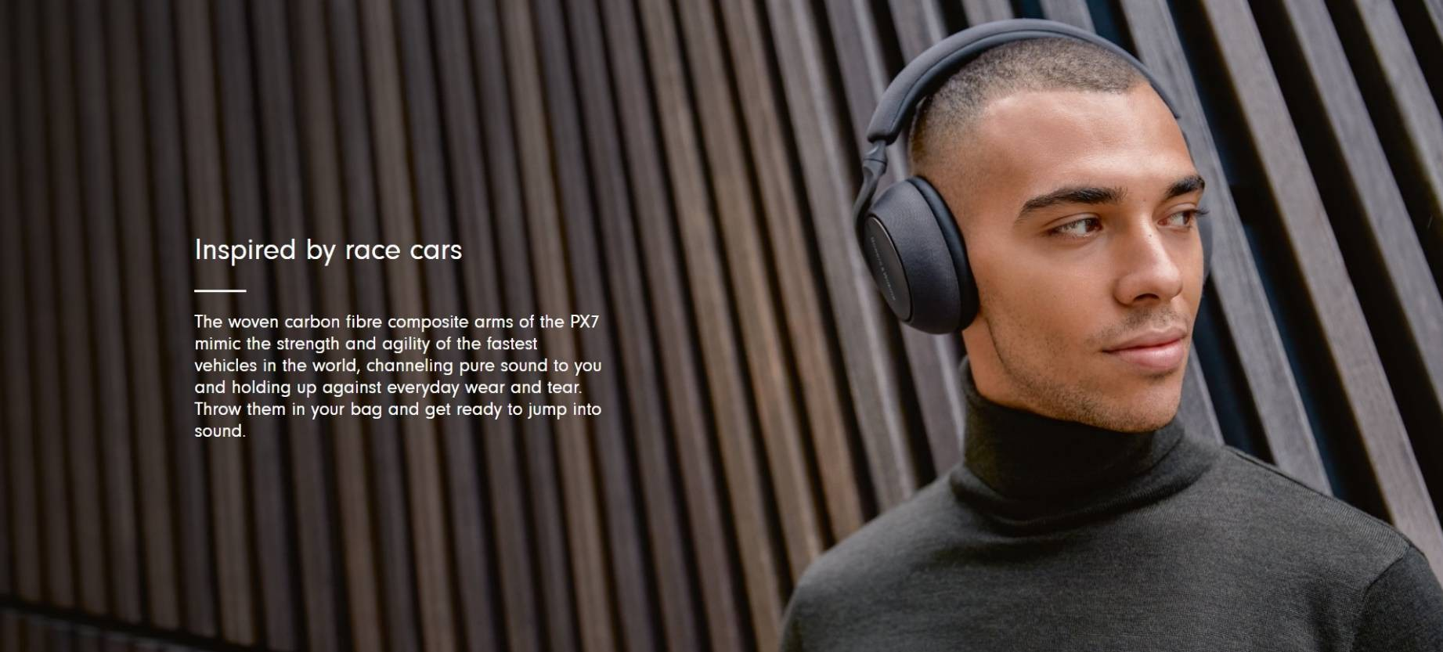

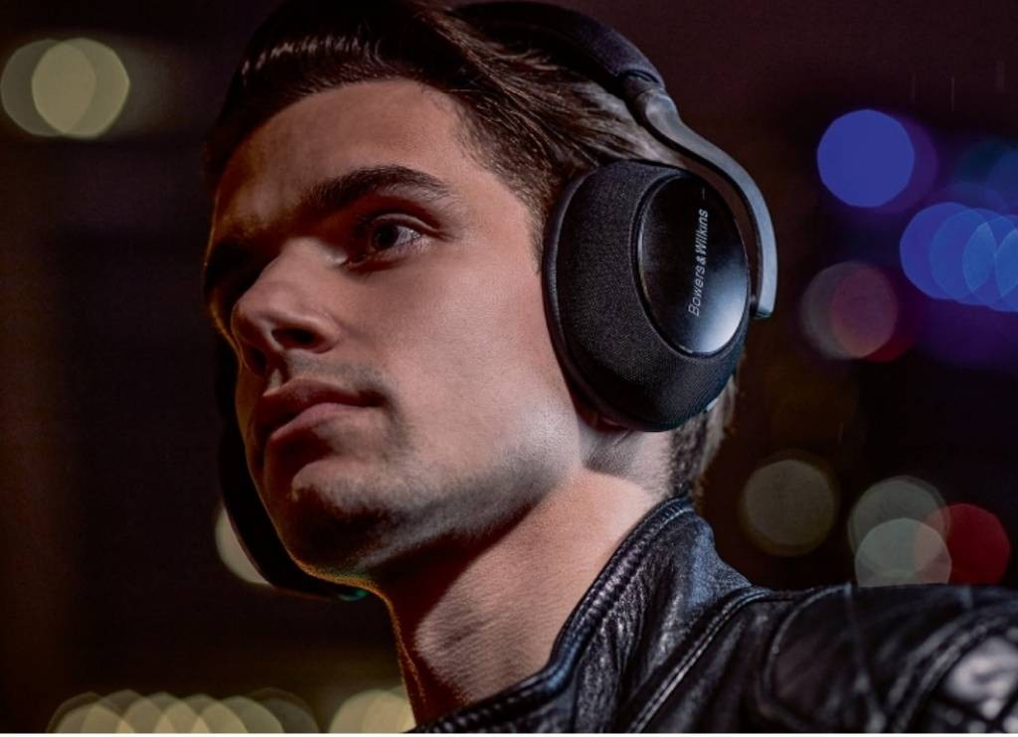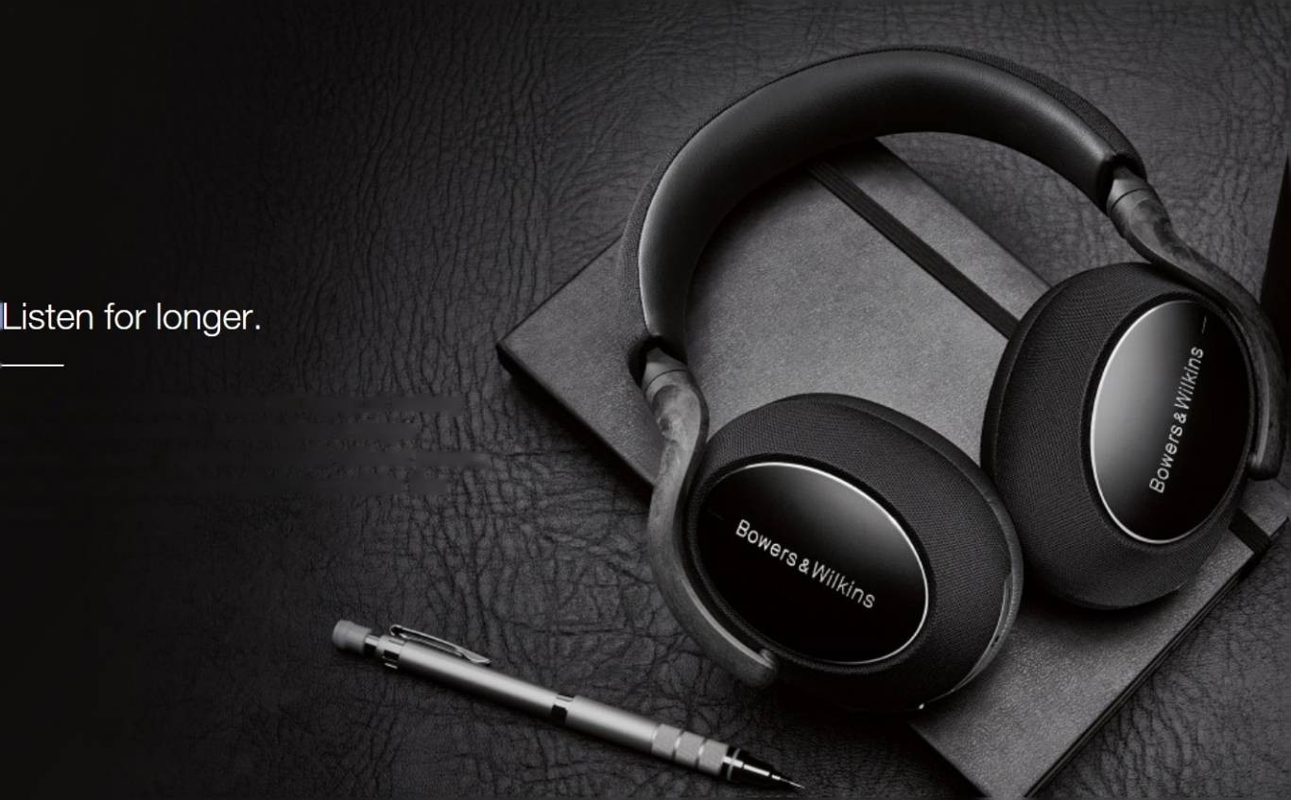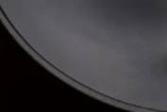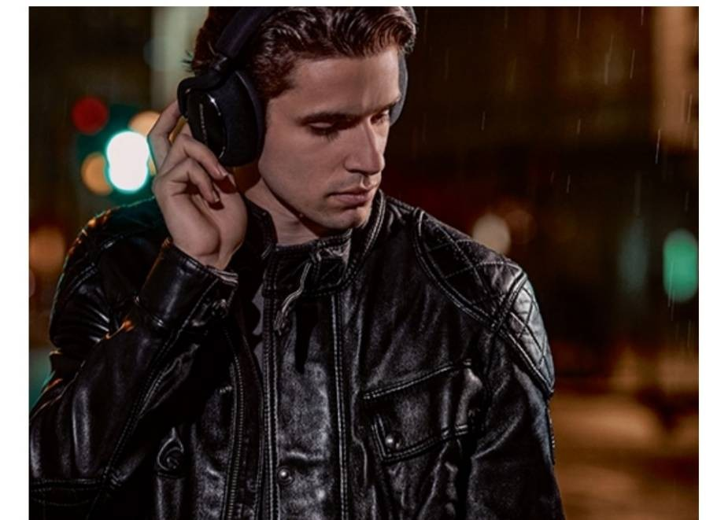PX7 Carbon Edition

PX7 Carbon Edition is a celebration of the PX7's carbon-fibre structure in a sleek new finish reminiscent of the design of our first headphones, the P5. And just like P5, PX7 Carbon Edition is tuned using decades of experience to deliver the best-possible mobile sound experience.

Engineered for performance.

We were inspired by the carbon-fibre engineering found in high-performance sports cars to create PX7 - its stiff yet lightweight construction maximises sound quality by reducing unwanted resonance without the burden of excess weight.

PX7 Carbon Edition offers 30 hours of battery life for uninterrupted listening on a single charge. Should you find yourself without power, a 15 minute quick-charge gives another five hours of listening.

Your wish, our command.

PX7 Carbon Edition obeys your every move. Lift an ear cup to hear what’s happening around you and your music automatically stops. Put it back and your music plays on.

